RabbitMQ Configuration

1.1        Dependency software

•         Install “Erlang” prior to installation of RabbitMQ

1.2        Enabling components

•         Run the below commands in DOS after installation of Rabbit MQ.

•         Go to the Path: “C:\Program Files\RabbitMQ Server\rabbitmq_server-3.7.7\sbin” and execute the below commands.

rabbitmq-plugins enable rabbitmq_management

rabbitmq-plugins enable rabbitmq_event_exchange

•

1.3        Access control configuration

•         Allow the firewall for inbound and outbound ports of 15672, 5672

•         Open RabbitMQ using “localhost:15672”

•         Default login user: guest, password: guest

•         Go to “Admin” Tab in the web page.

•         Enter “madhu” as user. It is case sensitive

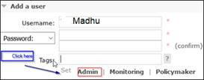

•         After Click on “Admin”. It looks as below.

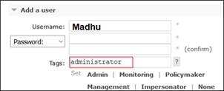

•         Click on “Add User”

•         “madhu” User will be created under Users section.

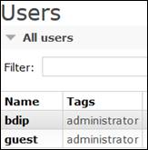

•         Click on “madhu” user.

Click on “Set Permission”, “Set topic permission”, “Update user”

Password need to be provided once again for “Update user”

